Unit 3: Linear Equations and inequalities
Lesson 3: Slope & Rate of change
Objectives:
- I can calculate the slope or the average rate of change from a table of values.
- I can calculate the slope or the average rate of change from a graph.
- I can calculate the slope or the average rate of change using ordered pairs.
- I can identify the slope’s different types
- I can identify the independent and dependent variables in a word problem.
- I can calculate the slope or the average rate of change from a word problem.
- I understand the meaning of the average rate of change in the context of the story.

Agenda:
- Video
- Practice
- Use all your skills
- Challenge yourself

Vocabulary:
- Slope, rate of change, ordered pairs, independent variable, dependent variable

Focus Questions:
- How can we calculate the average rate of change?
- What does the average rate of change represent in word problems?

Web support:
- https://www.khanacademy.org/math/algebra/two-var-linear-equations/slope/v/introduction-to-slope
- https://www.khanacademy.org/math/algebra/two-var-linear-equations/slope/v/positive-and-negative-slope

Web Practice:
- https://www.khanacademy.org/math/algebra/two-var-linear-equations/slope/e/slope-from-a-graph
- https://www.ixl.com/math/algebra-1/find-the-slope-from-two-points
- https://www.ixl.com/math/algebra-1/unit-rates

Homework: Finish your practice
Be prepared for quiz on Lesson 3-1 and lesson 3-2.

Do Now:

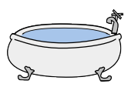
- Billy has an ancient bathtub that drains slower than usual. His sister, Sally, came to visit and wanted to know just how slow it drained so she filled the tub and let the water drain. Since Billy and Sally loved math, they modeled the results using the equation G $=-\frac{4}{3}t+20$, where $t$ represents minutes after they opened the drain and $G$ represents the number of gallons of water in the tub.

- What is the slope?

- What does the slope represent in the context of this problem?

- What is the y-intercept?

- What does the y-intercept represent in the context of this problem?

- How much time does it take for the tub to be completely empty?

- Given the linear equation, rewrite in slope intercept form when appropriate. Then identify the slope and y intercept.

0.4x + 0.7 y = 20 y = (2/5)x -4

Calculating average rate of change: Notes on slope formula:

Find the slope for the lines that go through the points listed in the following tables:

- 2.
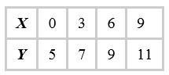
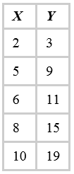

Find the slope of the line that goes through the ordered pairs using the formula:
- $\left(2,-4\right) , (3, -5)$ 2. $\left(3, 5\right) , ( -2,0)$

- $\left(1, 2\right) , (1, 4)$ 4. $\left(2, -7\right) (4, -7)$

Identify the 4 different types of slopes that you calculated working on all problems.

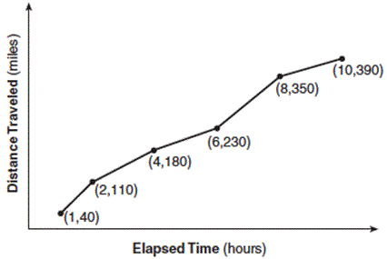

The Jamison family kept a log of the distance they traveled during a trip, as represented by the graph below.
During which interval was their average speed the greatest?
- the first hour to the second hour
- the second hour to the fourth hour
- the sixth hour to the eighth hour
- the eighth hour to the tenth hour

Now determine the average rate of change between the second hour and the tenth hour.

One more time:

- Chris is driving along a long-road at a constant speed. He is driving directly towards NYC. He knows that after 3-hours of driving he is 272 miles from NYC. After 4 and a half hours he is 176 miles from NYC.
- Identify the independent and dependent variables.

- Make a table of values to represent the information as two ordered pairs.

- Calculate the rate of change and explain what it means in the context of the story.

- You should have found that the rate of change is negative. Why is it? Explain what is physically happening to result in this negative rate of change.

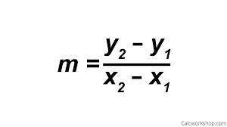
Name: ____________ Date: ____ Homework 3-3

The formula for the rate of change is:

Find the slope of the following lines:
- 2.
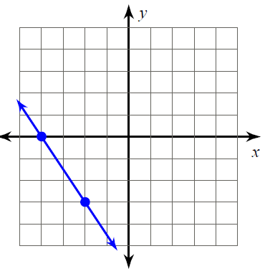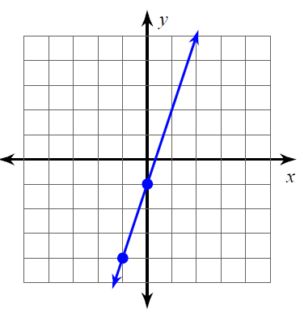

1. The following represents the graph for a helium balloon’s flight.
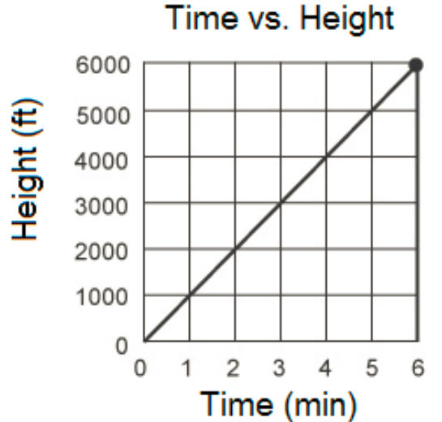
a. Determine the slope of the graph.

b. What does this slope (rate of change) mean in the context of the story?

C. write a possible equation for this story
Month | Saving ($)
1 | 400
2 | 500
4 | 700
6 | 900
12 | 1500

2The following represents the balance in Brady’s savings account.
- Find the rate of change.

- What does the rate of change mean in the context of the story?

c) find the y intercept

- A family is traveling from their home to a vacation resort hotel. The table below shows their distance from home as a function of time.
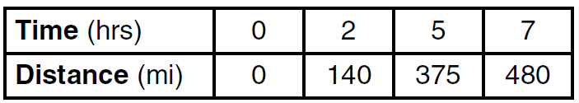
- Determine the average rate of change between hour 2 and hour 7, including units.

- What does the rate of change mean in the context of the story?

Calculate the slope from the given graphs.
